Cairns State Special School Tuckshop
Thursday Morning Tea
Name: | Class:
Snacks
 | Cupcake | $2.00
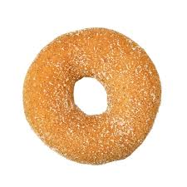 | Doughnut | $2.00
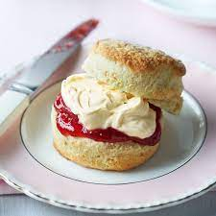 | Scones with jam and cream | $2.00
Drinks
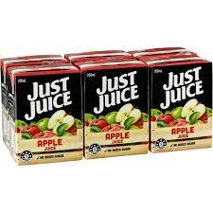  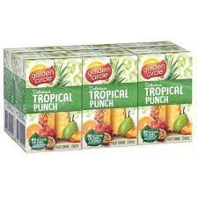 | Popper (apple, orange, tropical) | $2.00
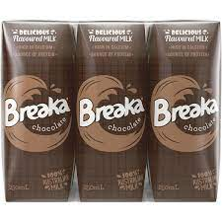 | Breaker (chocolate or strawberry) | $2.50

Hot food
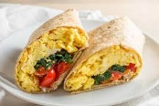 | Breaky wrap  (Scrambled egg, bacon, spinach, tomato) | $6.50
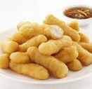 | Chicken nuggets x3 | $4.50
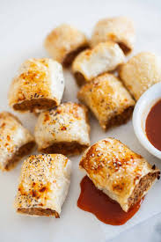 | Sausage rolls (3) | 3 for $5.00
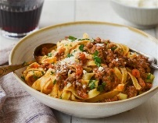 | Pasta Bolognaise | $6.50

Total amount

