Cairns State Special School Tuckshop
Thursday Lunch
Name: | Class:
Toasties
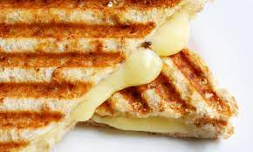 | Cheese  Ham & Cheese  Ham, Cheese & Tomato | $2.50  $3.50  $3.50
Wraps
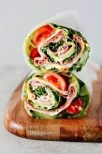 | Salad  Chicken & Salad  Ham & Salad | $5;00  $5.50  $5.50
Drinks
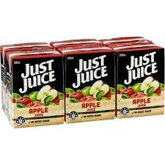  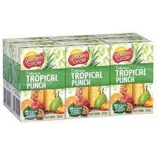 | Popper (apple, orange, tropical) | $2.00
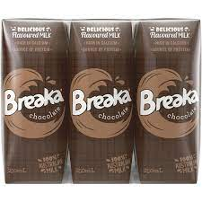 | Breaker (chocolate or strawberry) | $2.50

Main
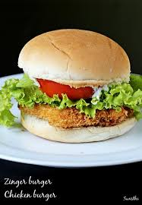 | Chicken burger  Lettuce, tomato, cheese, beetroot, mayo | $6.50
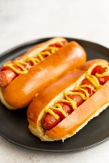 | Hot dog with cheese and sauce | $5.00
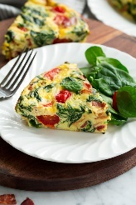 | Vegetable Frittata | $5.00
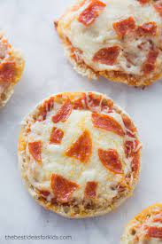 | Mini Pizza  Ham, cheese, pineapple | $4.50

Total amount

